

FACULTY OF COMPUTING AND TECHNOLOGY
UNIVERSITY OF KELANIYA

Numerical Data - Lab Worksheet 02

Student Name : M.A.L.Dilshani
Student Number : CT/2022/065

INTRODUCTION :

This lab worksheet focuses on numerical data processing using Java programming. The main purpose is to understand how to use mathematical formulas, operators, and user input to perform different calculations. These programs help to develop problem-solving skills and improve understanding of basic programming concepts.

DESCRIPTION OF THE LAB ACTIVITIES :

This lab worksheet includes several Java programs that perform different numerical calculations. We wrote programs to calculate square roots, cube roots, area of a circle, and other mathematical expressions. We also developed programs for unit conversions such as centimeters to feet and inches, and temperature conversions between Celsius and Fahrenheit. In addition, we created applications to calculate calories based on body weight, determine age using birth year, compute Body Mass Index (BMI), calculate the volume of a sphere, find investment growth, and compute loan payments. These activities helped us understand how to apply formulas, take user input, and display results clearly using Java.

IMPLEMENTATION :

Question 01:
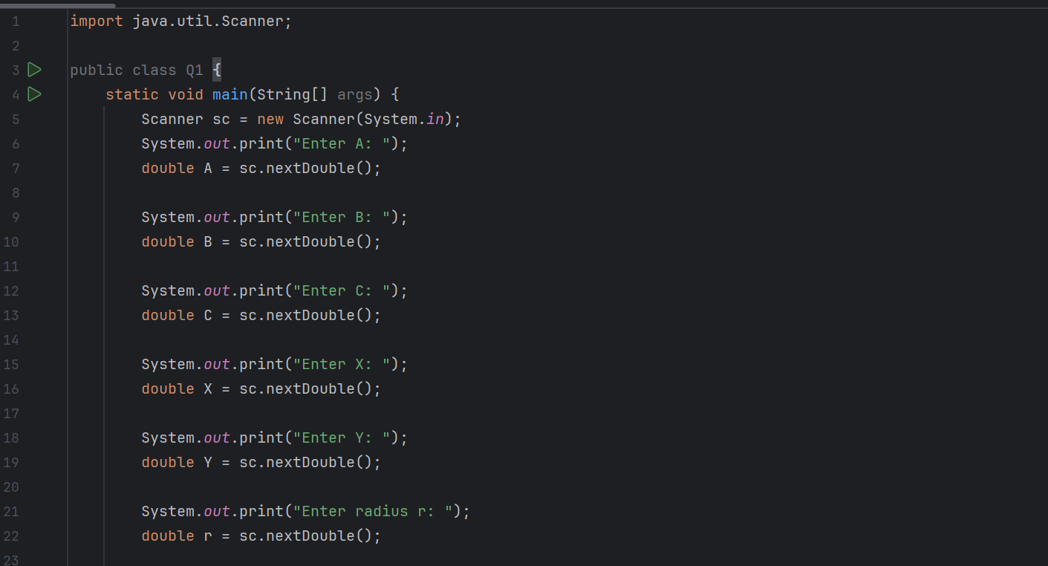
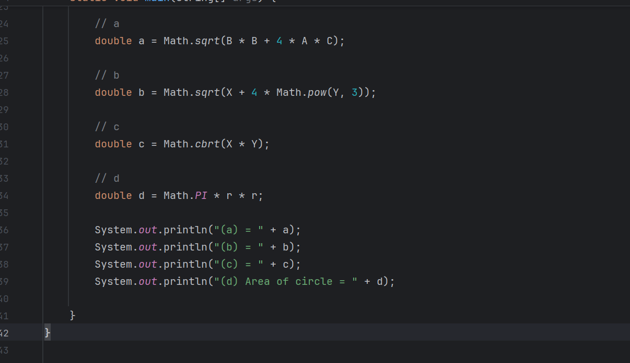

Output :

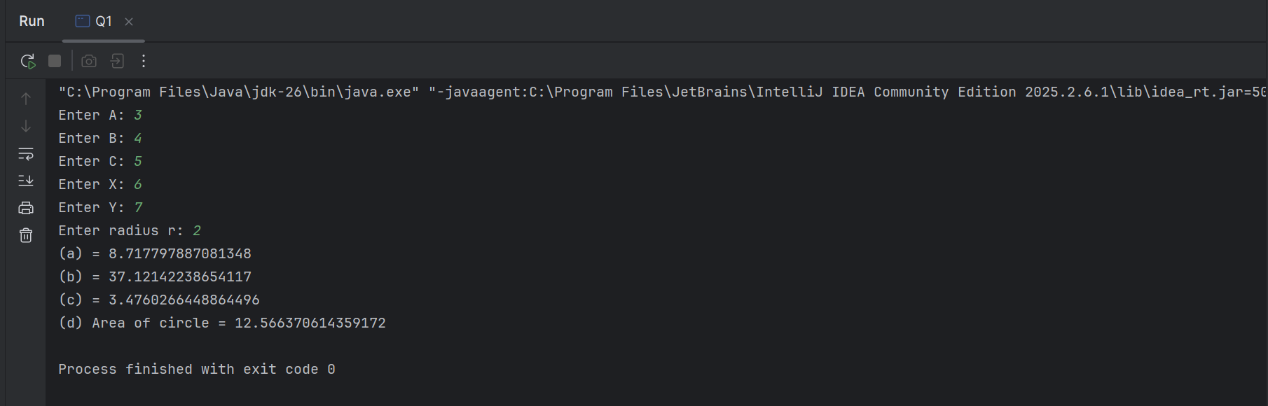

Question 02:
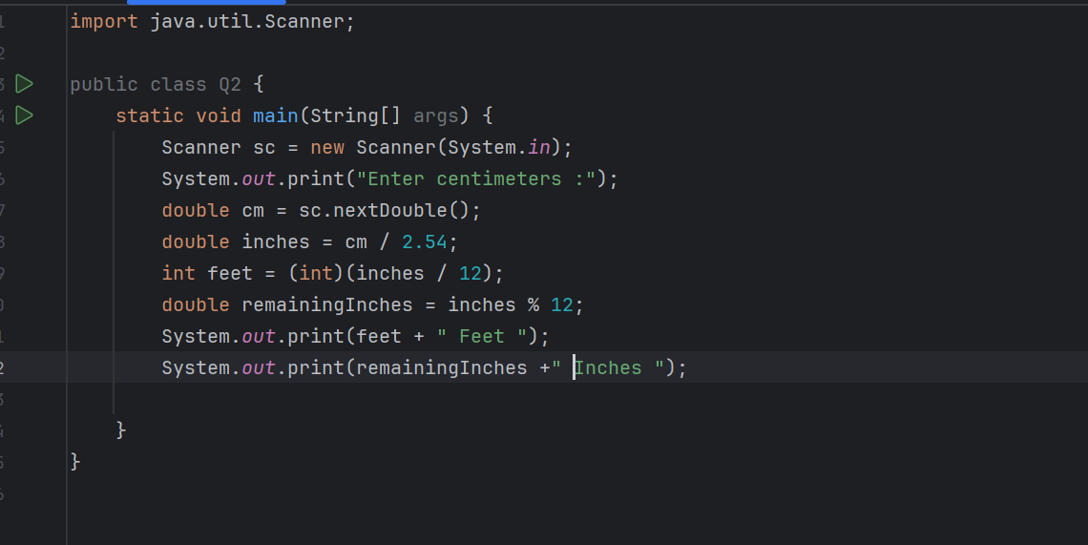

Output :
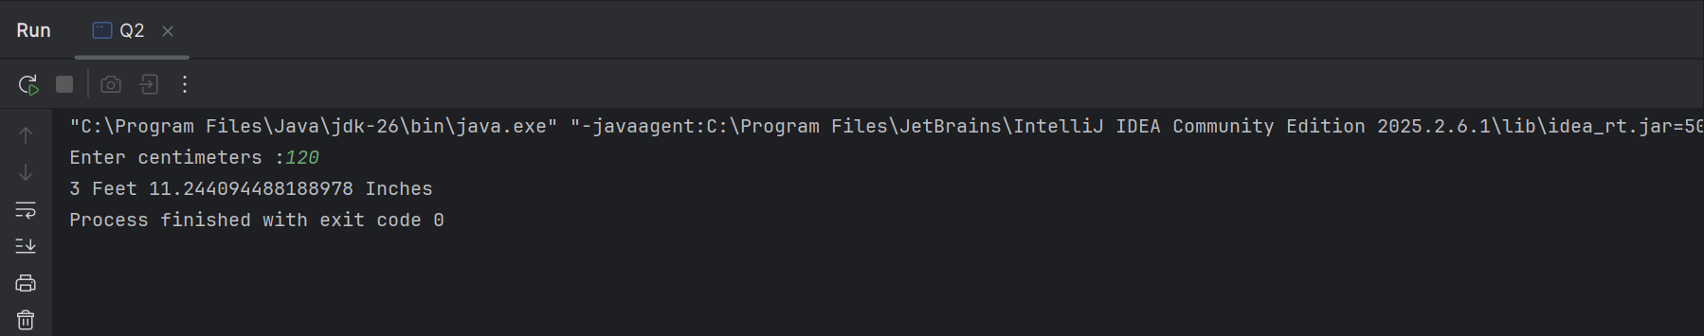
Question 03:
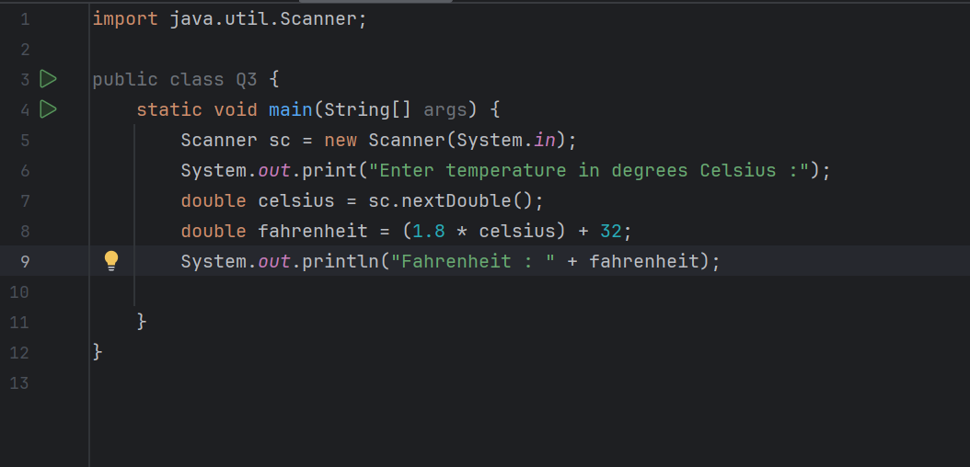
Output :
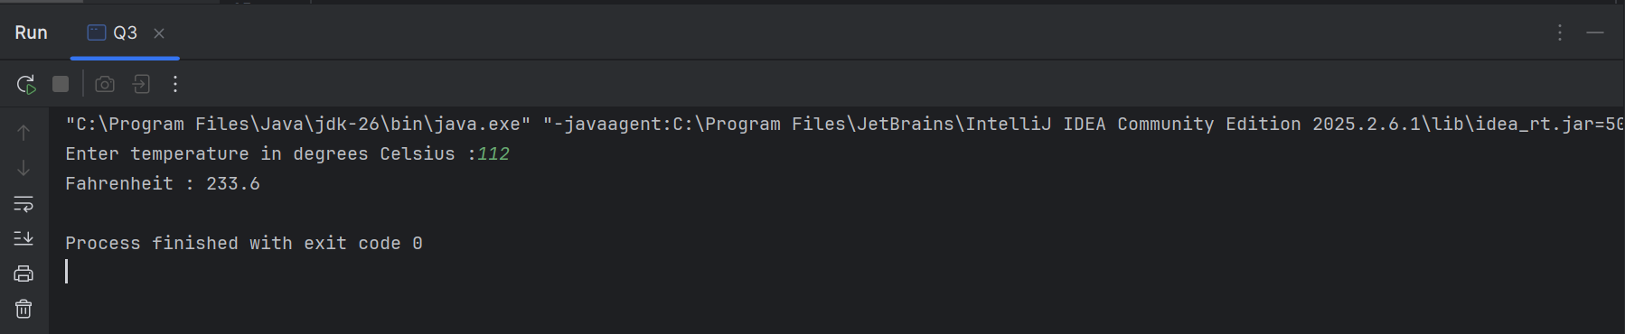

Question 04:
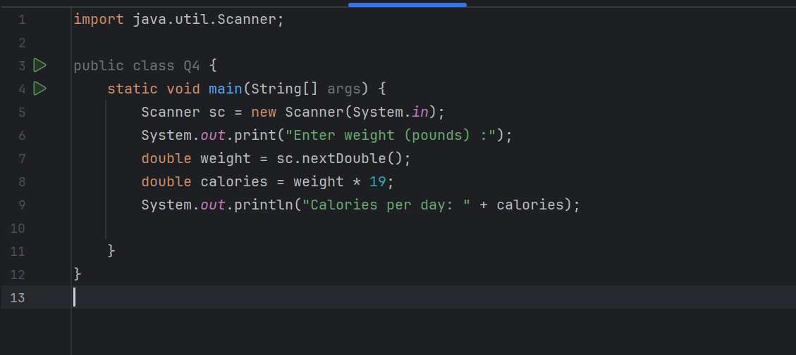
Output :

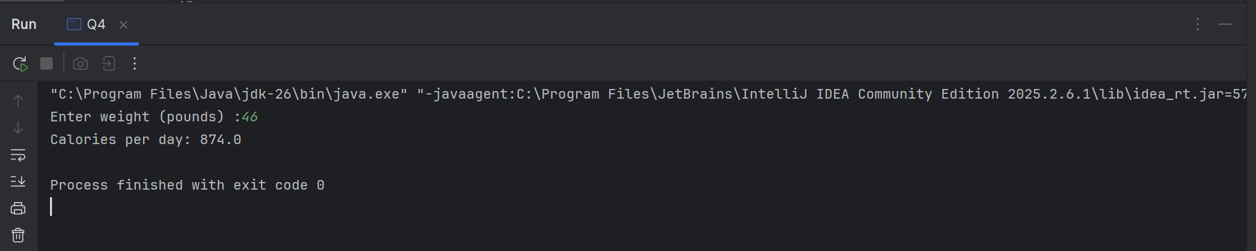

Question 05:

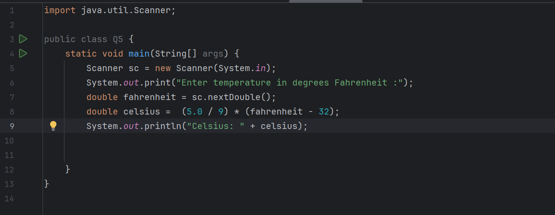

Output :

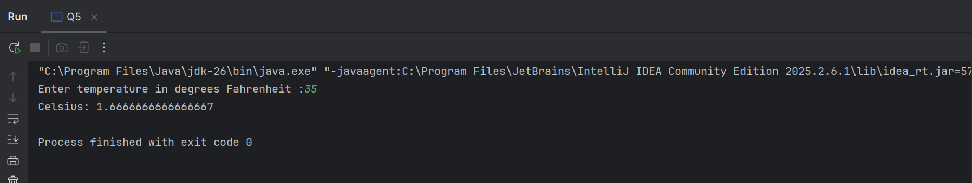

Question 06:

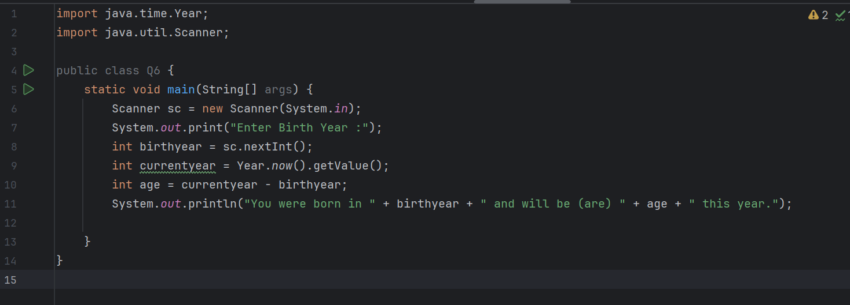
Output :

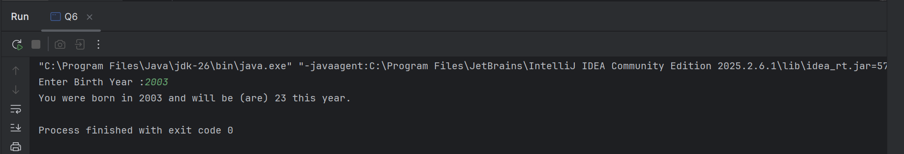

Question 07:

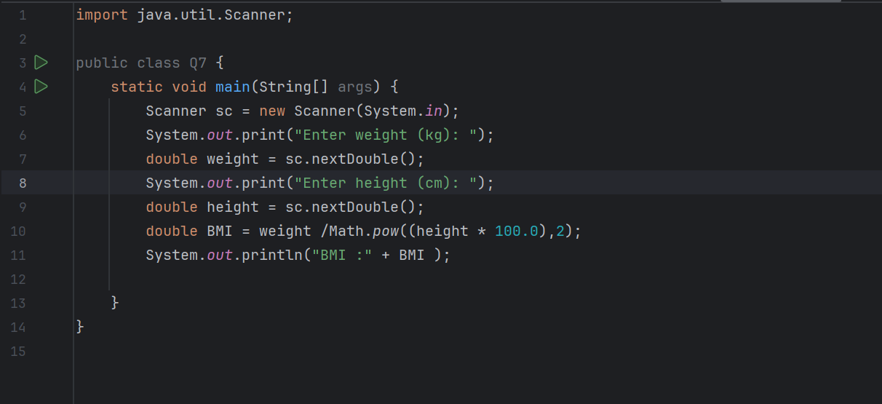
Output :

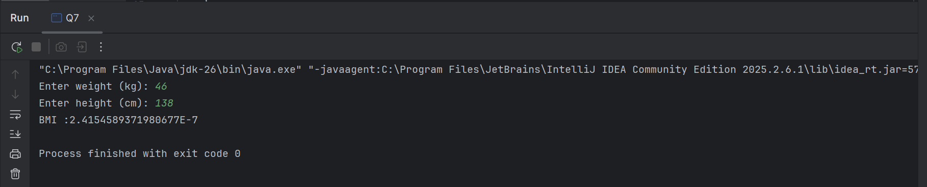

Question 08:

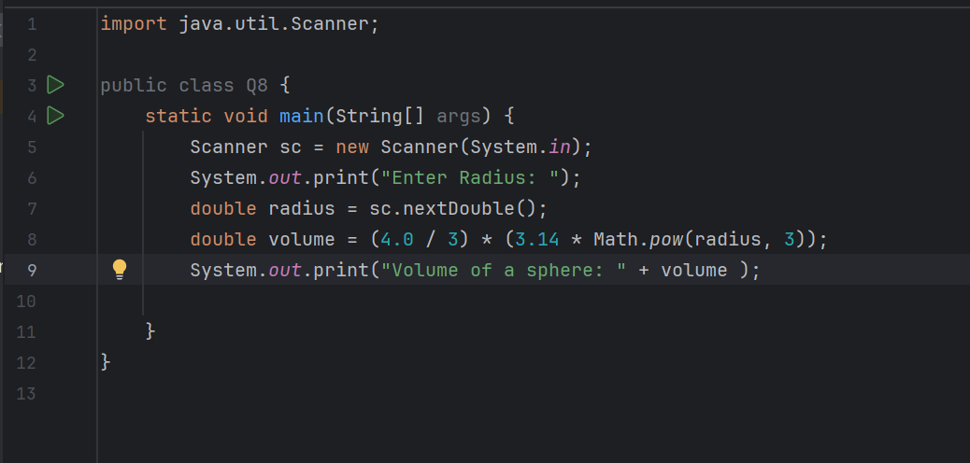

Output :

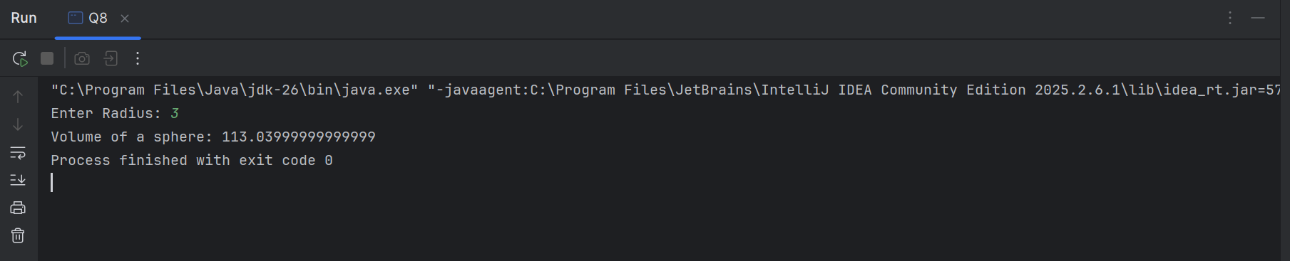

Question 09:

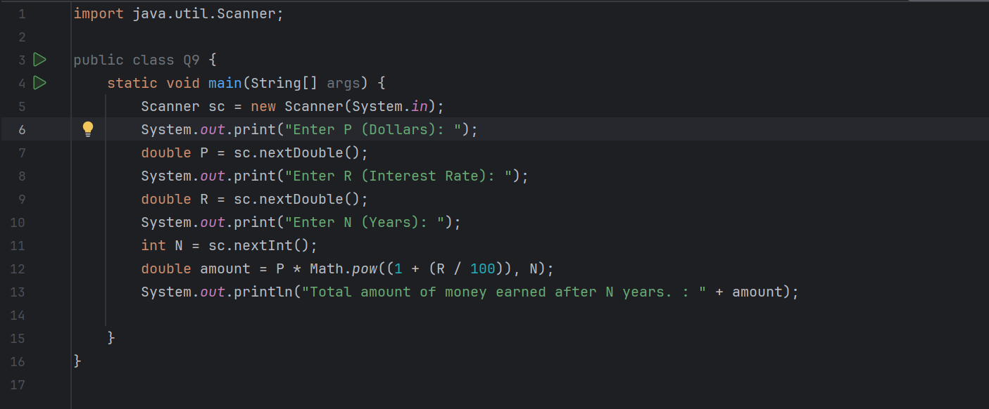

Output :

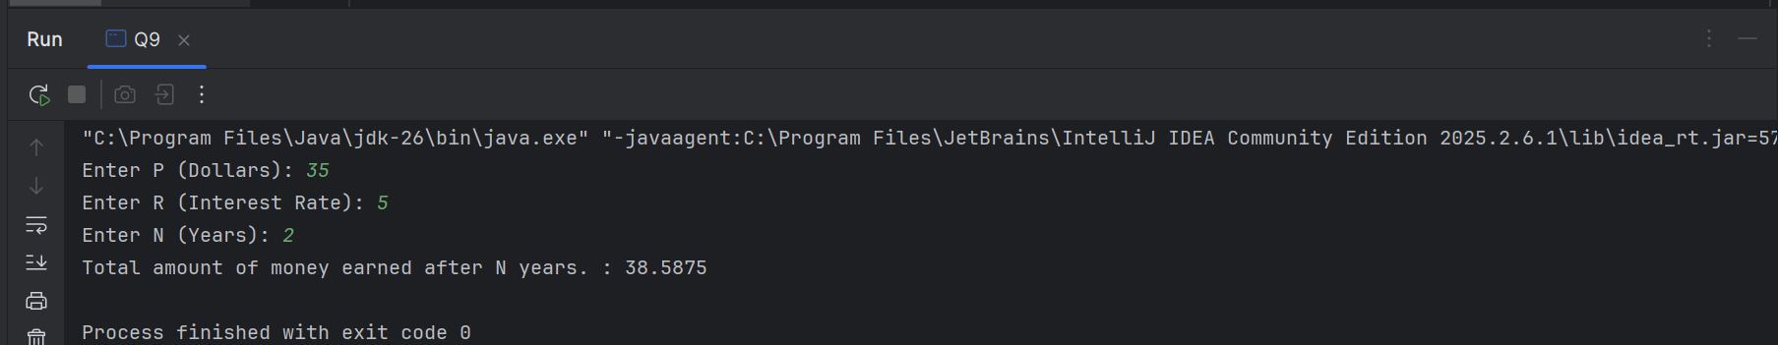

Question 10:
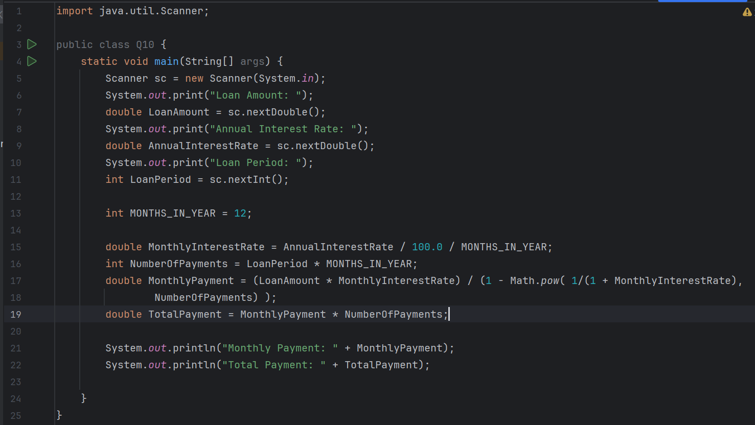
Output :
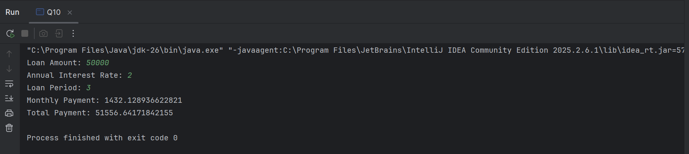

CONCLUSION :

This lab worksheet helped to improve understanding of numerical computations in Java programming. We learned how to use mathematical formulas, take user input, and perform different types of calculations. These skills are important for developing real-world applications and solving practical problems.

